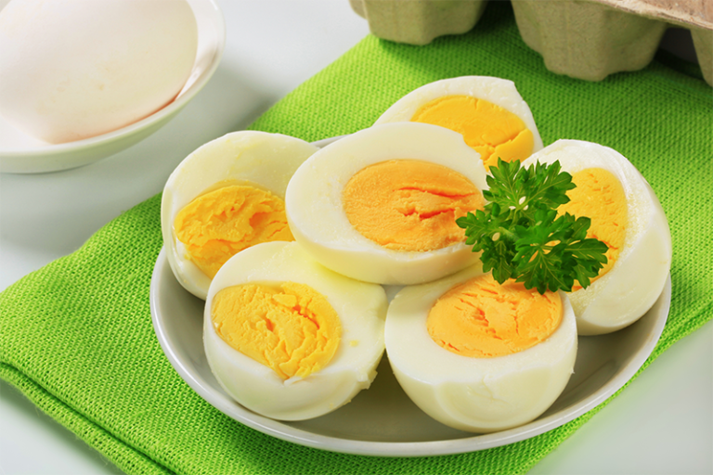
Cook’s Grocery & Delli – Ph: 732-463-1121
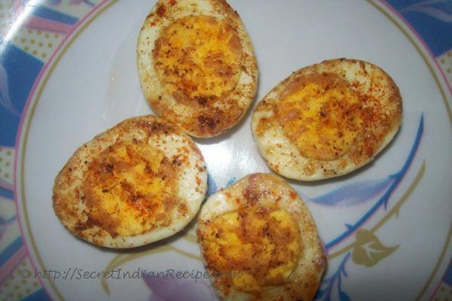
Boil

Boil Egg | Price: $2.99 Boil Fried Egge | Price: $3.99
Plain Boil Eggs Oil / Butter

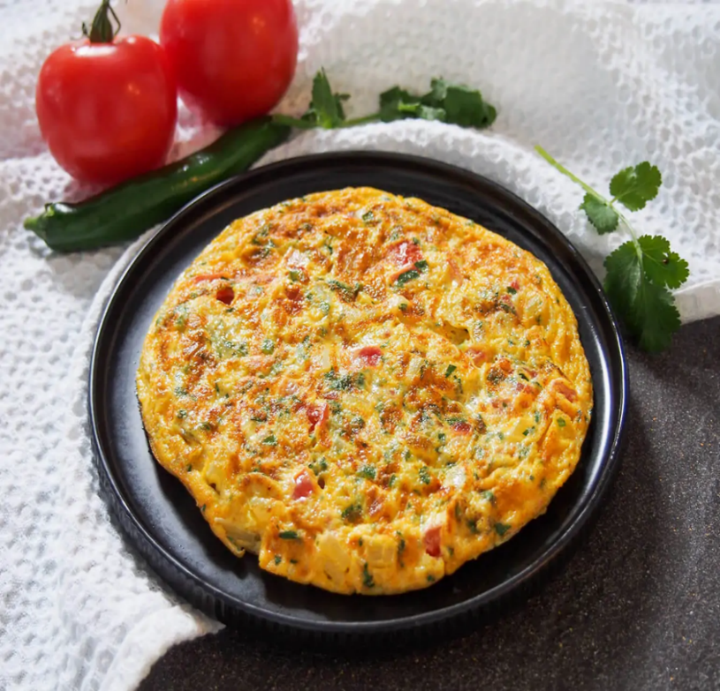
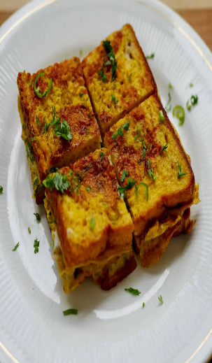

Omelet with Bread, Butter / Oil Price: $ 10.99
Onian, Ginger, Green Chili, Red chili powder, Salt, Turmeric, hot Masala

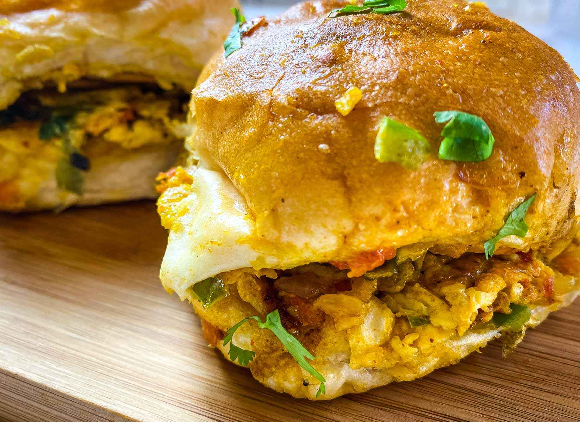
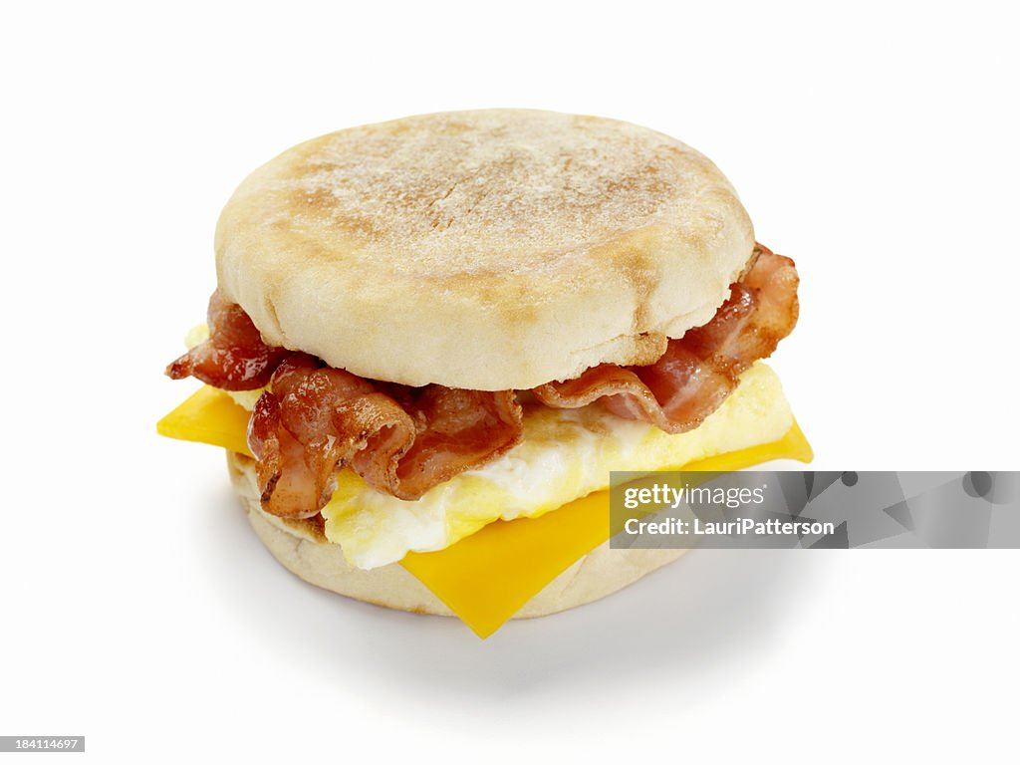

Omelet with Big bun 2 Eggs Bacon Egg & Cheese Jumbo
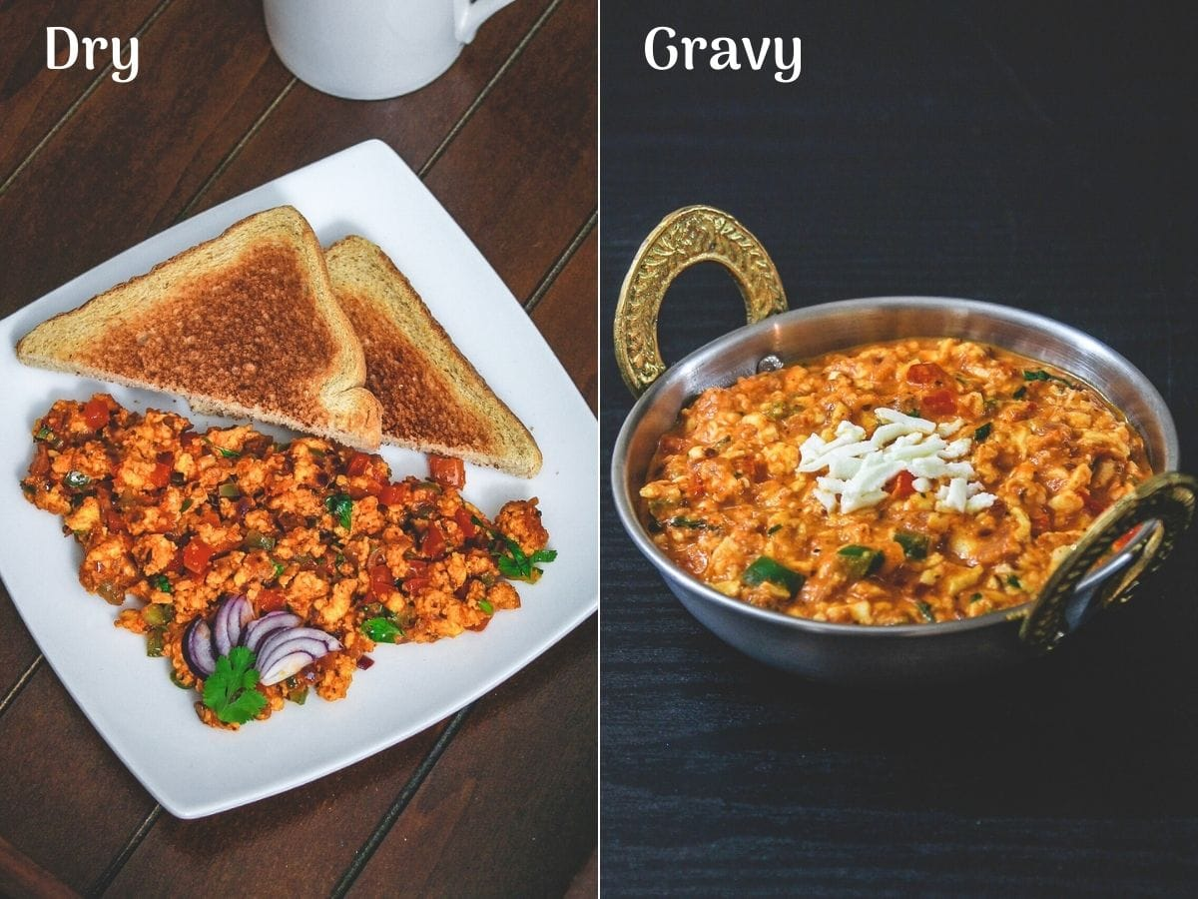
Price: $ 10.99 Price: $ 10.99

Egg Burji Dry / Egg Burji Gravy 2 cut Eggs Price: $10.99
Onian, Ginger, Green Chili, red chili powder, Salt, Turmeric, Hot Masala
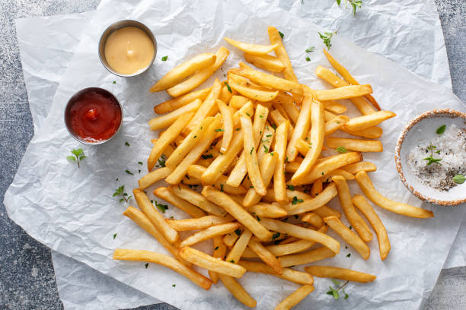
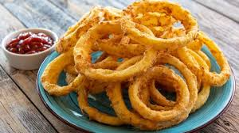

French Fry / Onion Rings Mi. Size Price $3.25

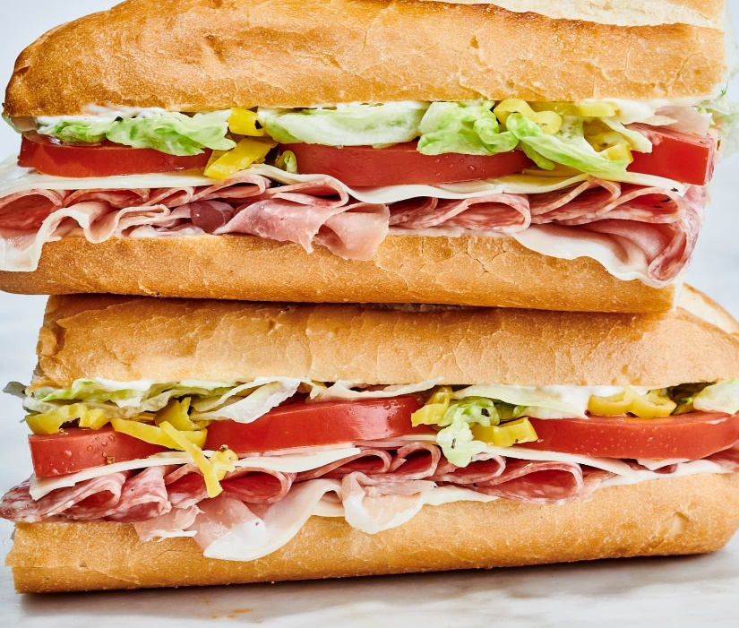

Sandwich Half: $7.75 Whole Price: $10.49
Veggies| Ham | Turkey | Pepperoni Cheese
Yello American, Swiss and Provolone cheese
Mayonnaise, Mustard, Ranch, Hot Peppers, Pickles, Oregano, Pickles

Sausage Egg & cheese Price: 9.99

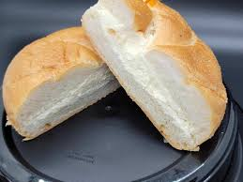
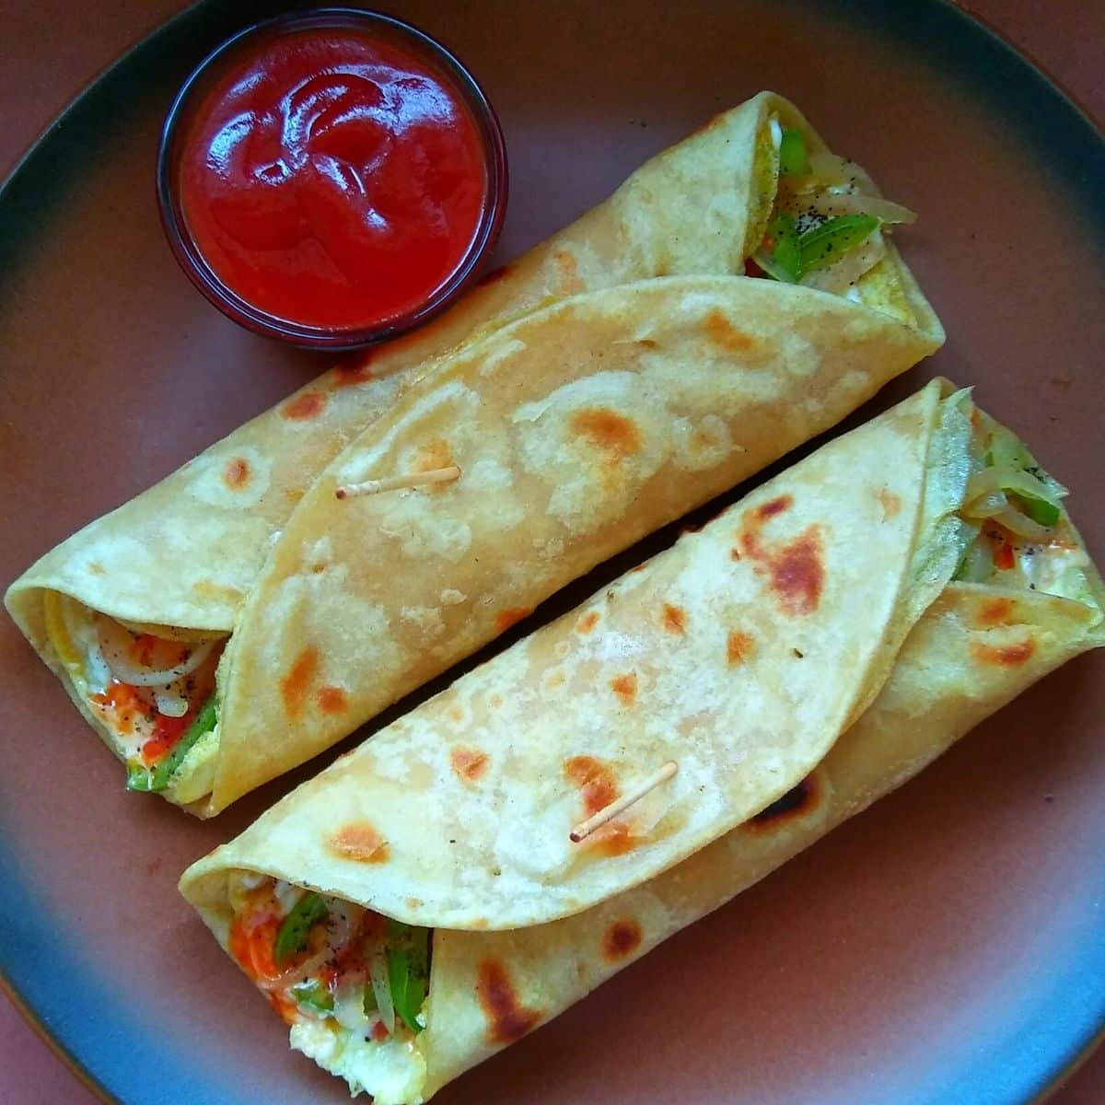

Egg Roll, Price: $10.99 Buttar /Cheam Cheese Roll, Price: $2.25
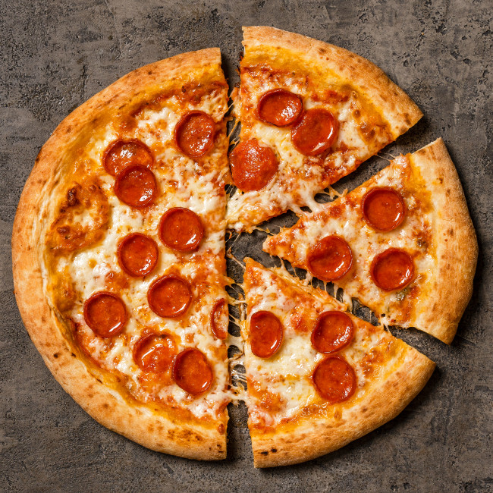
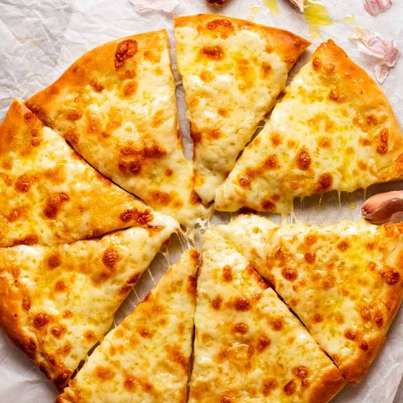

Pepperoni cheese 12 Inch Pizza Chess Pizza 12 Inch Pizza
Price: $ 9.99 Price: $ 8.99

Cook’s Grocery & Deli
399 Park Ave, Piscataway, NJ 08854
Phone: 732-463-1121 Deli Hours: 9 to 8 PM

Menu List
- Egg & Cheese……………………………………………………………… $9.99
- Bacon Egg & Cheese Jumbo……………………………………….…. $10.99
- Boil Egg…………………………………………………………………….. $2.99
- Boil Fried Egg…………………………………………………………….. $3.99
- Omelet with Bread……………………………………………………… $10.99
- Omelet with Big Bun…………………………………………………... $10.99
- Egg Bhurji Dry…………………………………………………………….. $10.99
- Egg Bhurji Gravy…………………………………………………………. $10.99
- Egg Roll……………………………………………………………………… $10.99
- French Fry………………………………………………………………….. $3.25
- Onion Rings……………………………………………………………….. $3.25
- Sandwith – Veggie, Ham, Turkey, Pepperoni (Half / Whole)...$7.75 | $10.99
- Buttar / Cream Cheese Roll…………………………………………. $2.25
- Special Winter Food…………………………………………………... $ 11.99

Please order on 732-463-1121 before 15/20 Minutes to take out
We will do all king of food combination

Thanks!

